**Machine Learning**

Machine learning is a branch of Artificial Intelligence that employs statistical methods to give computers the ability to learn and decide for themselves without being explicitly programmed. It is based on the idea that computers can learn from data, see patterns, and reach conclusions with little help from humans.

It belongs to the realm of artificial intelligence. It is the study of teaching robots to learn and create their own programs, so enabling them to behave and make decisions more like humans. With little to no explicit programming, this is accomplished. Based on the experiences of the machines throughout the process, the learning process is automated and enhanced. The computers are supplied high-quality data, and various methods are employed to create ML models to train the machines on this data. The kind of data at hand and the kind of action that needs to be automated will determine which algorithm is used.

* There are four sections of Machine learning such as supervised, unsupervised, semi-supervised and reinforcement.
* Let’s have look at the difference between Traditional programming and Machine learning:

In traditional programming, a human (the programmer) creates the program by hand. However, since the logic is not programmed, rules must be manually created or manually coded. On the other hand, in machine learning, the algorithm automatically creates the rules from the data.

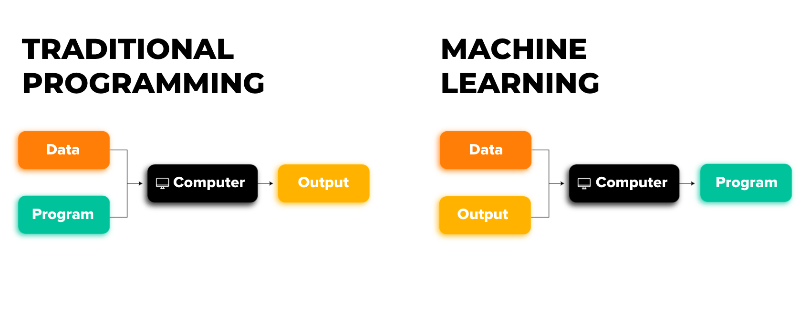

* Seven steps of Machine learning:

1. Gathering data
2. Preparing that data
3. Choosing a model
4. Training
5. Evaluation
6. Hyperparameter Tuning
7. Prediction

* There are some particular Terminology of Machine Learning like model, features, training, prediction, target, overfitting, underfitting.

**Advantage of Machine learning:**

Machine learning is an effective tool that may be used to solve many problems. It makes it possible for computers to learn from data without explicit programming. As a result of learning from past errors, it is feasible to develop systems that continuously improve their performance. Science, technology, and revolutions produced modernity. Machine learning is a technique for developing intelligent systems that can predict the future and make decisions based on facts. This can help organizations make decisions, enhance their operations, and create novel products and services. Healthcare, banking, and e-commerce are just a few of the numerous sectors that use machine learning extensively. You can pursue a number of different job prospects in these industries by learning machine learning. With numerous interesting advances and research opportunities, machine learning is a fast-expanding area. You can stay current with the most recent studies and advancements in the area by learning machine learning. Machine learning is a rapidly expanding field with countless possible applications. Machine learning algorithms can learn to recognize trends and patterns from historical data to assess likely outcomes. The program may replicate the process using current data and forecast the future using this as its reference framework.

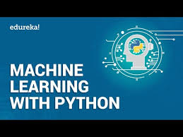

Machine learning with Python:

Computers may be taught to learn from data without being explicitly programmed using a technique called machine learning. Due to its abundance of strong libraries and frameworks that make machine learning algorithms simple to implement, Python is a well-known programming language for this purpose. Python is a general-purpose language, so it can do a variety of complicated machine learning jobs and make it simple to construct short prototypes for testing your product for machine learning.

Python is a crucial component of AI programming languages since it has effective frameworks like scikit-learn, which implements machine learning in Python and almost completely satisfies the needs in this field, and D3. js, which implements data-driven documents in JS. It is one of the easiest and most effective tools for visualizing.